**Q. 1 What are the benefits of using CSS?**

Actual use of CSS is to apply more than one style to the web site. There are many advantages

like…

* You can easily update more than one page view by updating single class.
* Class can be used across multiple web pages.
* It reduce HTML file size, so it's decrease loading time of site.
* CSS downloaded only once, that's why it's decreasing loading time for visitors.
* You can build animation, transitions and responsive web site by using the CSS
* Due to responsive designs user can easily work with site in mobile, tablet and also notebook.
* User can easily understand how the site works.

**Q. 2 What are the disadvantages of CSS?**

Disadvantages are like…

* Different browsers can describe CSS differently
* CSS became very complex in large projects, which is very tough to maintain.
* User can't use logic like conditions, loops and functions in it.
* Large CSS file slow down the speed to web page.
* Any single changes destroys too many effects in the site.
* Overriding the CSS means user have to take too much care about class name.

**Q. 3 What is the difference between CSS2 and CSS3?**

|  |  |
| --- | --- |
| **CSS2** | **CSS3** |
| CSS2 is inflexible. | CSS3 is flexible with separate modules. |
| Very few features compare to CSS3 | Too many new features updated in it like…  Box, Color, Background and Borders, Text Effect, Selectors, Animation, Transition, Grid Layout, Media Query etc. |
| Supported and compatible with most modern browser. | Fully supported and compatible to any browser. |
| Due to old features performance is limited. | Performance is better due to new features added in it. |

CSS2 don't having flex, mediaquery, selectors, pseudocode etc while you can easily use it in CSS3

**Q. 4 Name a few CSS style components.**

CSS having two types of style components.

1. **Properties** : The identifiers which specify which style you are applying in css.

2. **Value** : Value applying with the identifiers to perform what we want to do.

Which explain in example as shown below.

**Code:**

<!DOCTYPE html>

<html lang="en">

<head>

    <meta charset="UTF-8">

    <meta name="viewport" content="width=device-width, initial-scale=1.0">

    <title>Document</title>

    <style>

        * {

            padding: 0;

            margin: 0;

        }

        body {

            display: flex;

            position: absolute;

            margin-top: 100px;

            margin-left: 100px;

        }

        .main {

            padding: 20px;

            width: 300px;

            height: 300px;

            border: 2px solid navy;

            background-color: bisque;

        }

        .head {

            font-style: italic;

            font-size: 40px;

            font-weight: bold;

            font-family: sans-serif;

            color: red;

            margin-bottom: 20px;

        }

        .content1{

            font-weight: bold;

            font-size: 20px;

            margin-bottom: 20px;

        }

        .content2{

            font-style: italic;

            font-size: 20px;

        }

    </style>

</head>

<body>

    <div class="main">

        <p class="head">Properties and Value Example</h1>

        <p class="content1">The identifiers which specify which style you are applying in css.</p>

        <p class="content2">Value applying with the identifiers to perform what we want to do.</p>

    </div>

</body>

</html>

**Output :**

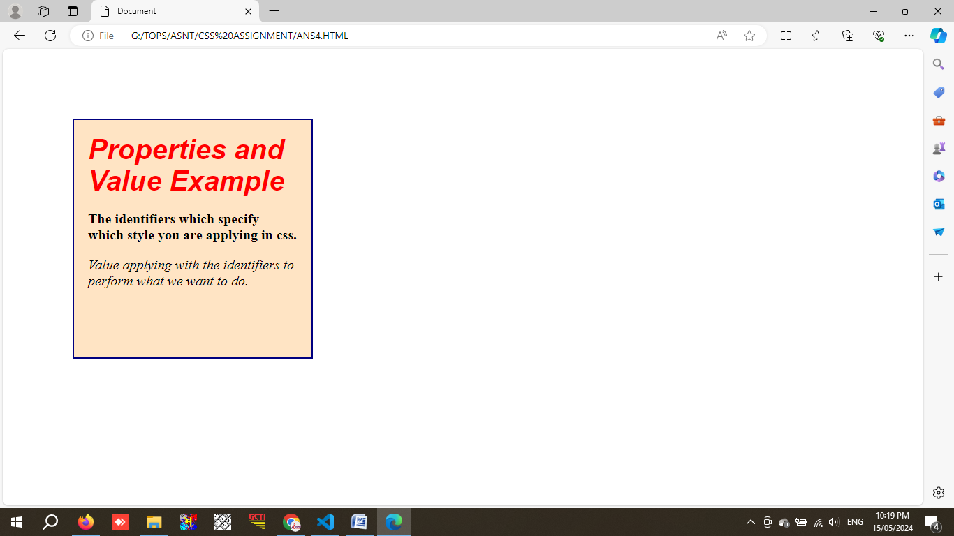

**Q. 5 What do you understand by CSS opacity?**

Opacity is used to increase / decrease color transparency.

Where **1** **is not transparent** and **0.25** is **25%** transparency, while **0** is **100%** transparent.

**Code :**

<!DOCTYPE html>

<html lang="en">

<head>

    <meta charset="UTF-8">

    <meta name="viewport" content="width=device-width, initial-scale=1.0">

    <title>Document</title>

    <style>

        * {

            padding: 0;

            margin: 0;

        }

        .main {

            display: flex;

            margin-top: 100px;

            margin-left: 100px;

            padding: 20px;

            justify-content: space-around;

        }

        h1{

            color:navy;

            font-family: sans-serif;

        }

        .image1 {

            width: 250px;

            height: 150px;

            opacity: 25%;

            margin-top: 20px;

        }

        .image2 {

            width: 250px;

            height: 150px;

            opacity: 50%;

            margin-top: 20px;

        }

        .image3 {

            width: 250px;

            height: 150px;

            opacity: 75%;

            margin-top: 20px;

        }

    </style>

</head>

<body>

    <div class="main">

        <div>

            <h1>25% Opacity</h1>

            <img src="7BKG.png" class="image1">

        </div>

        <div>

            <h1>50% Opacity</h1>

            <img src="7BKG.png" class="image2">

        </div>

        <div>

            <h1>75% Opacity</h1>

            <img src="7BKG.png" class="image3">

        </div>

    </div>

</body>

</html>

**Output :**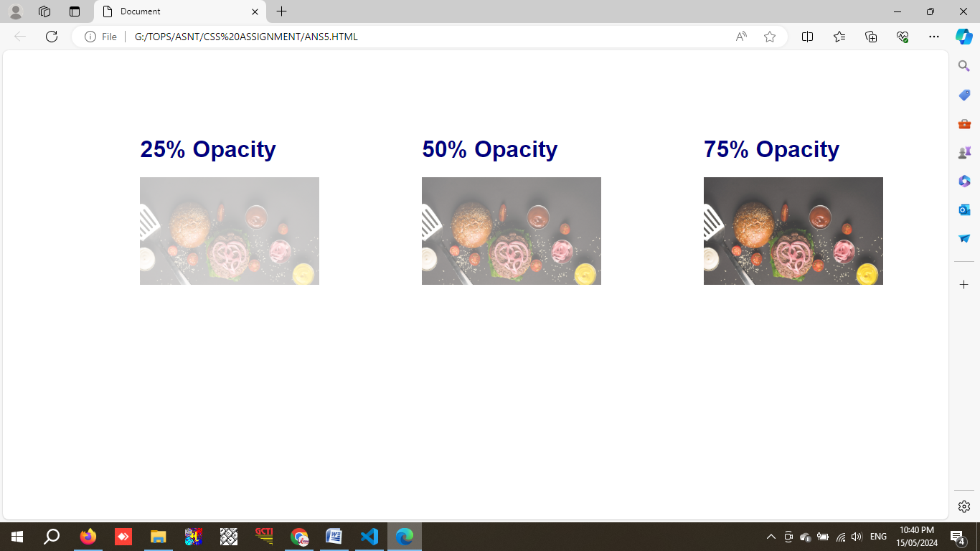

**Q. 6 How can the background color of an element be changed?**

With the help of **background-color: red;** we can change the background color with red effect.

**Code :**

<!DOCTYPE html>

<html lang="en">

<head>

    <meta charset="UTF-8">

    <meta name="viewport" content="width=device-width, initial-scale=1.0">

    <title>Document</title>

    <style>

        * {

            padding: 0;

            margin: 0;

        }

        .main {

            Display: flex;

            border: 3px solid black;

            height: 600px;

            width: 800px;

            margin-top: 25px;

            margin-left: 200px;

            padding: 10px;

            display: grid;

            grid-template-columns: auto auto auto;

            gap: 10px;

        }

        #one1 {

            background-color: blue;

        }

        #one2 {

            background-color: red;

        }

        #one3 {

            background-color: yellow;

        }

        #one4 {

            background-color: green;

        }

        #one5 {

            background-color: orange;

        }

        #one6 {

            background-color: orangered;

        }

        #one7 {

            background-color: cyan;

        }

        #one8 {

            background-color: pink;

        }

        #one9 {

            background-color: violet;

        }

    </style>

</head>

<body>

    <div class="main">

        <div id="one1">Blue</div>

        <div id="one2">Red</div>

        <div id="one3">Yellow</div>

        <div id="one4">Green</div>

        <div id="one5">Orange</div>

        <div id="one6">Orangered</div>

        <div id="one7">Cyne</div>

        <div id="one8">Pink</div>

        <div id="one9">Violet</div>

    </div>

</body>

</html>

**Output :**

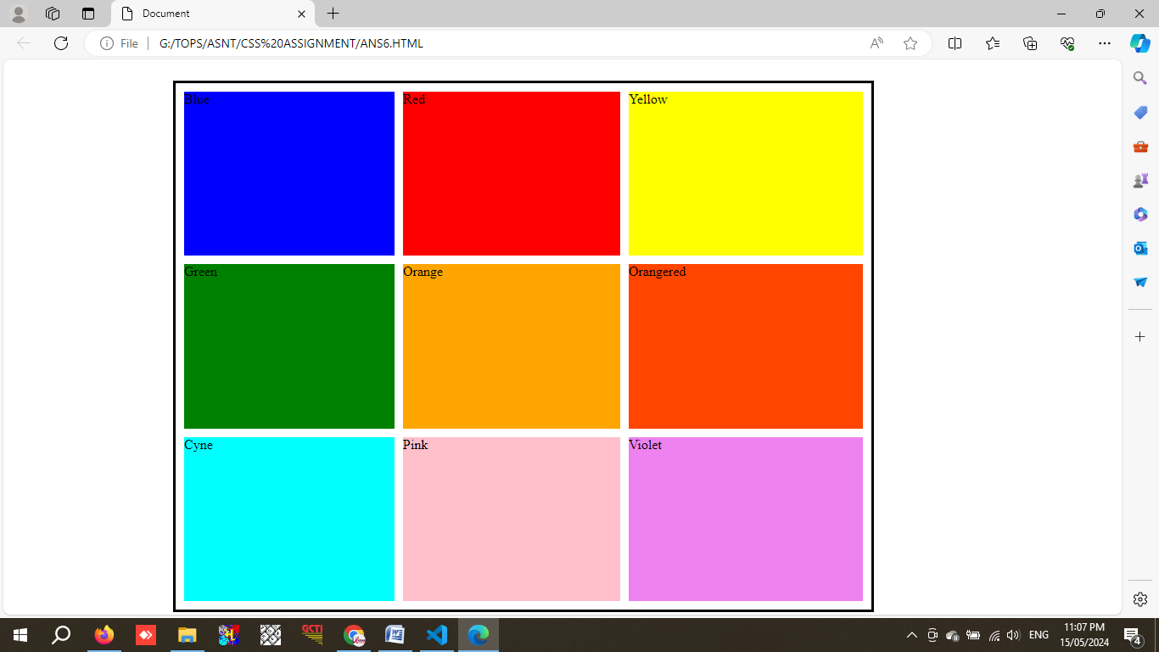

**Q. 7 How can image repetition of the backup be controlled?**

**Background-repeat** is used to control the repetition by **x / y axis** and also restrict the repetition by **no-repeat** value.

**Code :**

<!DOCTYPE html>

<html lang="en">

<head>

    <meta charset="UTF-8">

    <meta name="viewport" content="width=device-width, initial-scale=1.0">

    <title>Document</title>

    <style>

        * {

            padding: 0;

            margin: 0;

        }

        .main {

            height: 100vh;

            Color: brown;

        }

        .main1 {

            height: 250px;

            width: 900px;

            border: 2px solid black;

            background-image: url('7BKGREPEAT.png');

            background-repeat: repeat-x;

            margin-bottom: 20px;

        }

        .main2 {

            height: 350px;

            width: 900px;

            border: 2px solid black;

            background-image: url('7BKGREPEAT.png');

            background-repeat: repeat-y;

            margin-bottom: 20px;

        }

        .main3 {

            height: 250px;

            width: 900px;

            border: 2px solid black;

            background-image: url('7BKGREPEAT.png');

            background-repeat: no-repeat;

        }

    </style>

</head>

<body>

    <div class="main">

        <H1>repeat-x Example</H1>

        <div class="main1"> </div>

        <H1>repeat-y Example</H1>

        <div class="main2"></div>

        <H1>no-repeat Example</H1>

        <div class="main3"></div>

    </div>

</body>

</html>

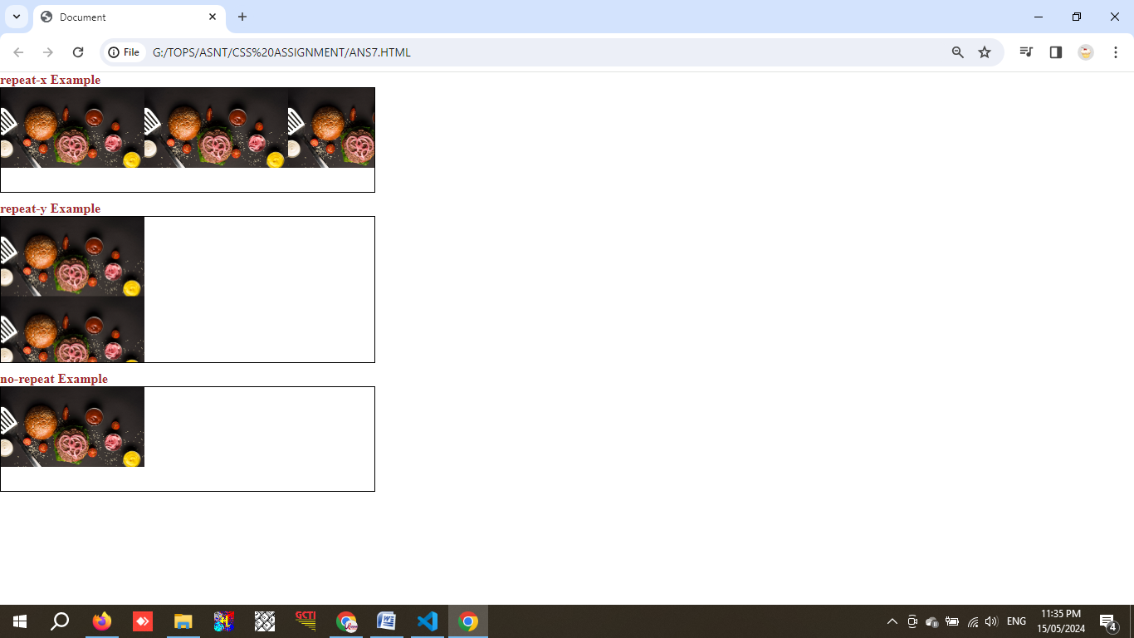**Output :**

**Q. 8 What is the use of the background-position property?**

Background-position is used to set image behind the text with many options like **center, top, bottom** andasper **x & y px** also.

**Code :**

<!DOCTYPE html>

<html lang="en">

<head>

    <meta charset="UTF-8">

    <meta name="viewport" content="width=device-width, initial-scale=1.0">

    <title>Document</title>

    <style>

        * {

            padding: 0;

            margin: 0;

        }

        .main {

            margin-top: 100px;

            margin-left: 10px;

            display: flex;

            height: 100vh;

            Color: blue;

        }

        .main1 {

            height: 250px;

            width: 430px;

            border: 2px solid black;

            background-image: url('7BKGREPEAT.png');

            background-repeat: no-repeat;

            margin-bottom: 20px;

            background-position: bottom;

        }

        .main2 {

            height: 250px;

            width: 430px;

            border: 2px solid black;

            background-image: url('7BKGREPEAT.png');

            background-repeat: no-repeat;

            margin-bottom: 20px;

            background-position: top;

        }

        .main3 {

            height: 250px;

            width: 430px;

            border: 2px solid black;

            background-image: url('7BKGREPEAT.png');

            background-repeat: no-repeat;

            background-position-x: 32px;

            background-position-y: 12px;

        }

    </style>

</head>

<body>

    <div class="main">

        <div class="main1"><h1>Position - Bottom</h1></div>

        <div class="main2"><h1 style="margin-top:205px">Position - Top</h1></div>

        <div class="main3"><h1 style="margin-top:205px">Position - x & y axis</h1></div>

    </div>

</body>

</html>

**Output :**

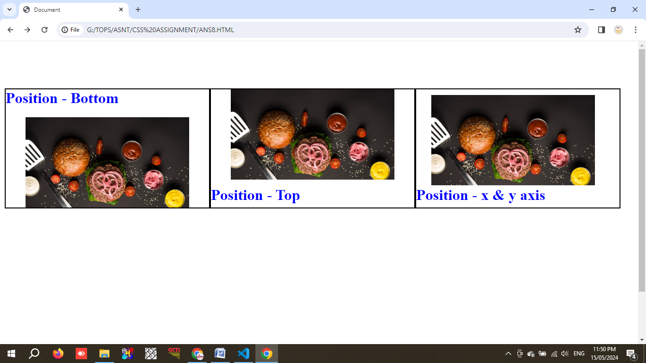

**Q. 9 Which property controls the image scroll in the background?**

**Background-attachment** is used to control the image scroll with the value of **fixed** in the background while foreground content get scrolled.

**Code :**

<!DOCTYPE html>

<html lang="en">

<head>

    <meta charset="UTF-8">

    <meta name="viewport" content="width=device-width, initial-scale=1.0">

    <title>Document</title>

    <style>

        * {

            padding: 0;

            margin: 0;

        }

        body {

            background-image: url(7BKGREPEAT.png);

            background-repeat: no-repeat;

            background-attachment: fixed;

        }

        p{

            font-size: 20px;

            font-weight: bold;

            color: yellow;

        }

    </style>

</head>

<body>

    <p>

        lorem1000 word [ text not posted - Reason : to save the file size. ]

    </p>

</body>

</html>

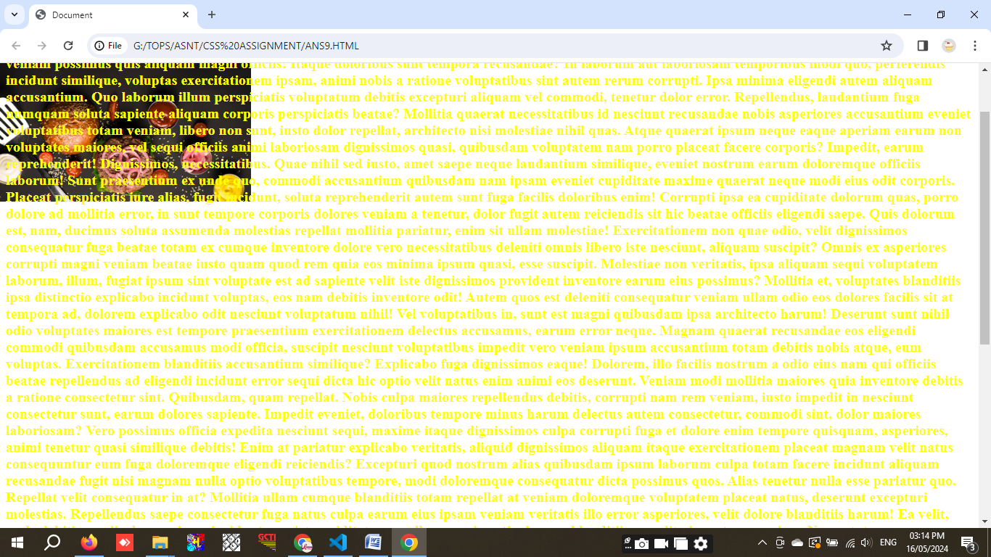**Output :**

**Q. 10 Why should background and color be used as separate properties?**

**Background** property is used for background with it’s value like **color, position, attachement** etc., while **color** is used to apply color effect to the text in front of background.

**Code :**

<!DOCTYPE html>

<html lang="en">

<head>

    <meta charset="UTF-8">

    <meta name="viewport" content="width=device-width, initial-scale=1.0">

    <title>Document</title>

    <style>

        .main {

            height: 200px;

            width: 200px;

            border: 2px solid black;

            background-color: navy;

            color: white;

            font-size: 30px;

            text-align: center;

        }

    </style>

</head>

<body>

    <div class="main">

        I am text in front of Background.

    </div>

</body>

</html>

**Output :**

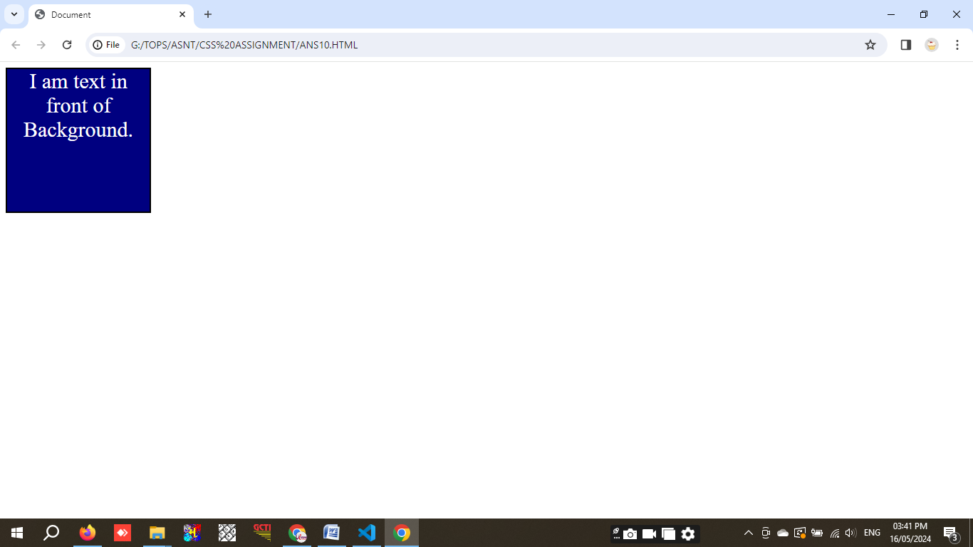

**Q. 11 How to center block elements using CSS1?**

**center** tag is used to center block elements using css1.

**Code :**

<!DOCTYPE html>

<html lang="en">

<head>

    <meta charset="UTF-8">

    <meta name="viewport" content="width=device-width, initial-scale=1.0">

    <title>Document</title>

    <style>

        .box {

            position: flex;

            Height: 200px;

            width: 200px;

            border: 2px solid navy;

            align-items: center;

            align-content: center;

            font-size: 30px;

        }

    </style>

</head>

<body>

    <center>

        <div class="box">Hello !</div>

    </center>

</html>

**Output :**

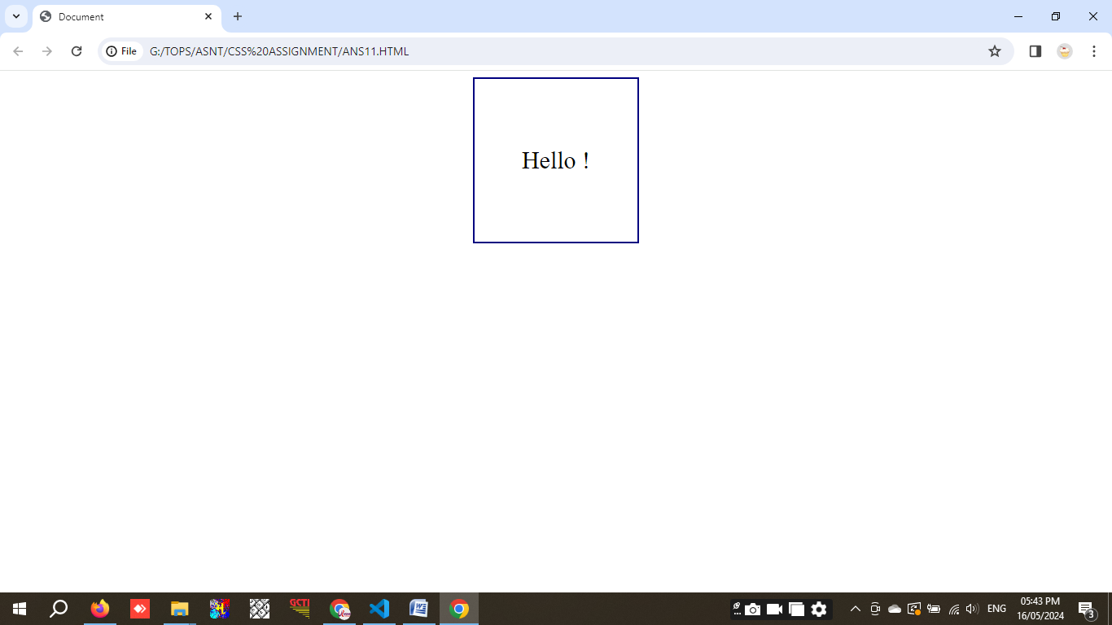

**Q. 12 How to maintain the CSS specifications?**

To maintain the CSS carefully, user must have follow basic rules to improve the performance.

1. Use of modules : Instead of creating the large CSS file, divide CSS into part as per the module of pages of site.
2. Naming rule : Provide the class name as per it's use.

e.g., .image to display image, .image-expand to expand image

1. Must specify comment with code to understand easily.
2. Create responsive design and use media queries to visible in small screen size.
3. Maintain documentation of your CSS to explain the use of CSS modules.

**Q. 13 What are the ways to integrate CSS as a web page?**

There are three ways to integrate CSS as a web page as shown below.

1. **Inline CSS :** Adding styles directly in to the HTML elements using style attribute.

**Code :**

<!DOCTYPE html>

<html>

<head>

    <title>Inline CSS Example</title>

</head>

<body>

    <h1 style="color: navy; text-align: center; font-weight: bold;">I am Inline CSS Example.</h1>

</body>

</html>

**Output :**

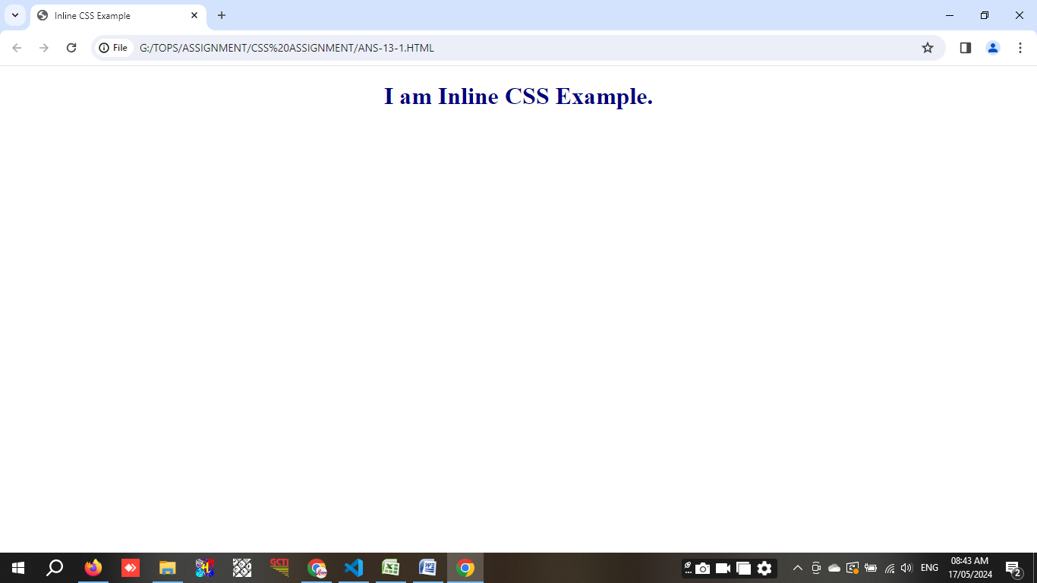

1. **Internal CSS :** CSS placed inside <head> section using <styles> tag is called internal CSS.

**Code :**

<!DOCTYPE html>

<html>

<head>

    <title>Internal CSS Example</title>

    <style>

        body {

            background-color: rgb(255, 225, 230);

        }

        h1 {

            color: Navy;

            text-align: center;

        }

    </style>

</head>

<body>

    <h1>I am Internal CSS Example.</h1>

</body>

</html>

**Output :**

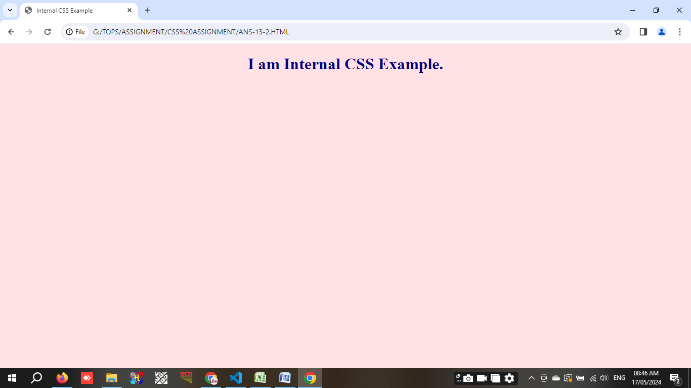

1. **External CSS :** This types of CSS is preferred for large projects. Saved with .css extension and linked with HTML file with <link> tab inside <head> tag. Internal style sheet is also known as Embedded style sheet.

**Code :**

HTML FILE

<!DOCTYPE html>

<html>

<head>

    <title>External CSS Example</title>

    <link rel="stylesheet" type="text/css" href="ANS-13-3.CSS">

</head>

<body>

    <h1>I am External CSS Example</h1>

</body>

</html>

CSS FILE

body {

    background-color:lightskyblue;

}

h1 {

    color: navy;

    text-align: center;

}

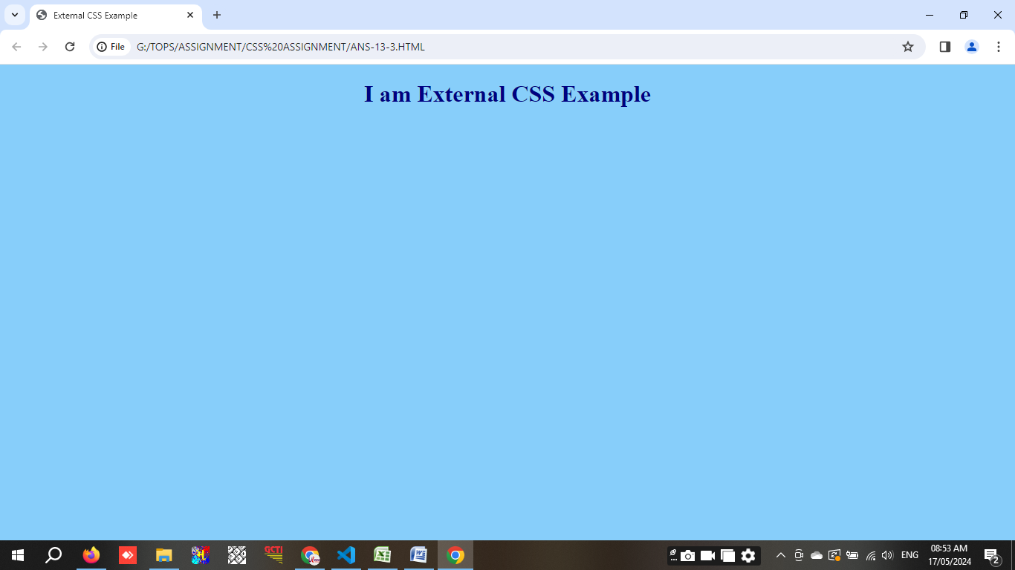**Output :**

**Q. 14 What is embedded style sheets?**

Embedded style sheet is also known as internal style sheet. It's placed within **<style></style>** in **<head>** section. It's maximum used in single page website.

**Code :**

<!DOCTYPE html>

<html>

<head>

    <title></title>

    <style>

        body {

            background-color: lightyellow;

        }

        h1 {

            color: brown;

            text-align: center;

        }

        p {

            font-size: 16px;

            color: blue;

            text-align: center;

        }

    </style>

</head>

<body>

    <h1>Hello, World!</h1>

    <p>This is an example of using embedded style sheets.</p>

</body>

</html>

**Output :**

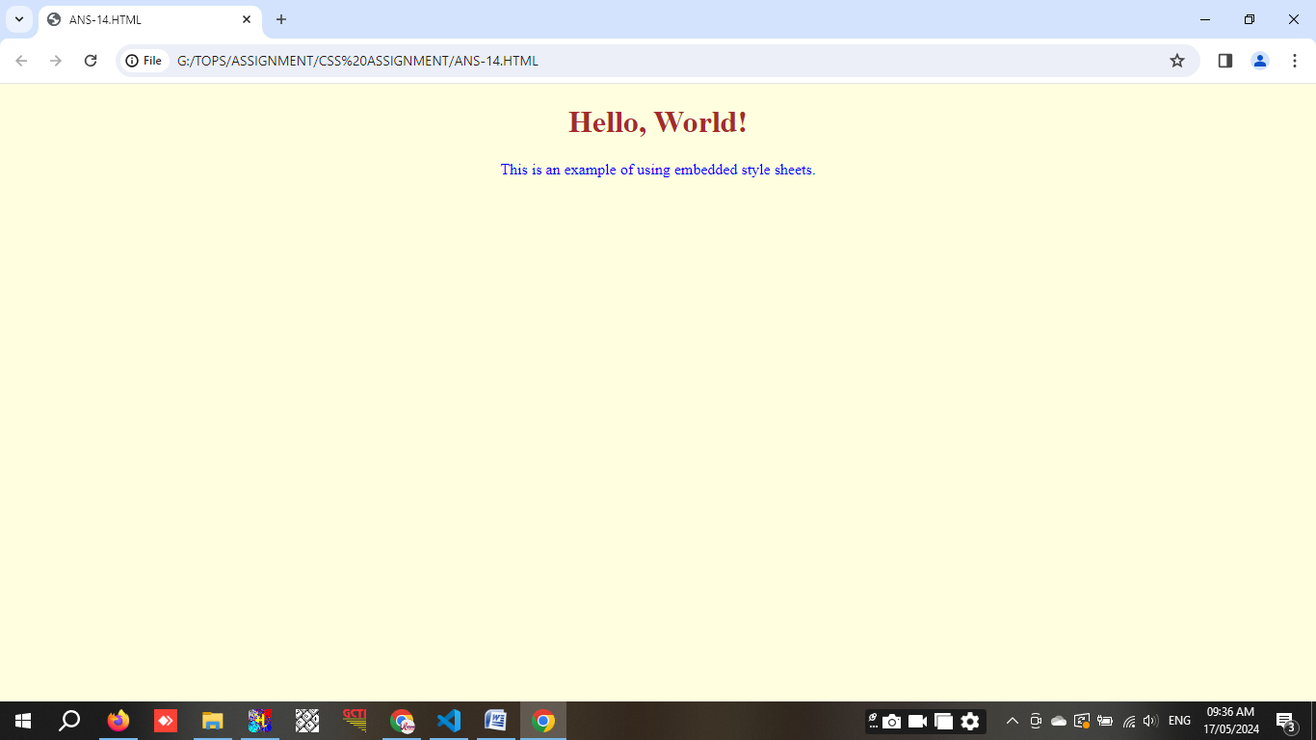

**Q. 15 What are the external style sheets?**

This types of CSS is preferred for large projects. Saved with **.css** extension and linked with **HTML** file with **<link>** tab inside **<head>** tag. Internal style sheet is also known as embedded style sheet.

**Code :**

HTML File

<!DOCTYPE html>

<html>

<head>

    <title>External Style Sheets Example</title>

    <link rel="stylesheet" type="text/css" href="ANS15.CSS">

</head>

<body>

    <h1>External Style Sheet.</h1>

    <p>This is an example of an external style sheet.</p>

</body>

</html>

CSS File

body {

    background-color: rgb(180, 234, 255);

  }

  h1 {

    color: brown;

    text-align: center;

  }

  p {

    font-size: 16px;

    color: darkslategray;

    text-align: center;

  }

**Output :**

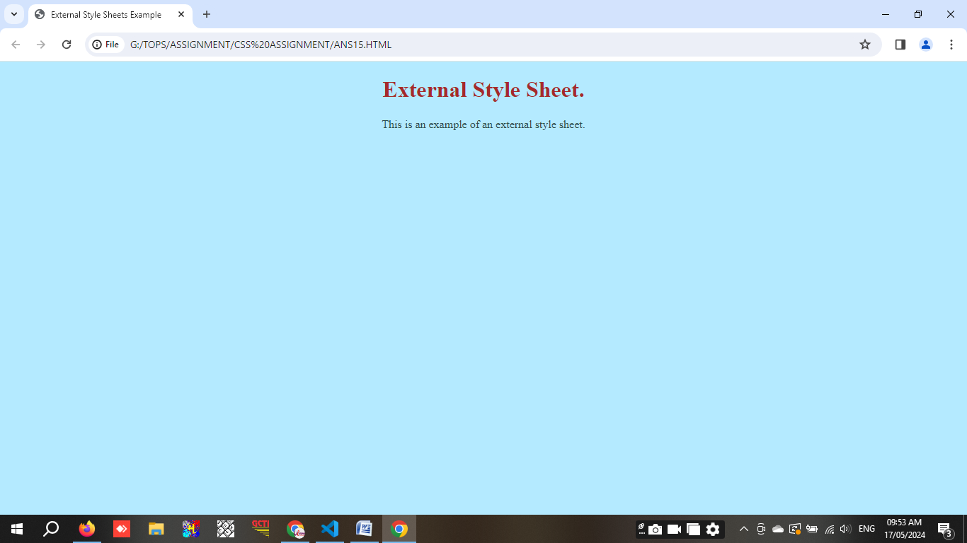

**Q. 16 What are the advantages and disadvantages of using external style sheets?**

**Advantages of Using External Style Sheets**

1. Easy to maintain by separating HTML and CSS file.
2. Change in CSS will make change in design of HTML.
3. CSS once downloaded than browser doesn't need to download CSS file again and again, which decrease loading time.
4. Reducing the HTML file size by separating the CSS file.
5. HTML file is more understandable due to separating CSS file.
6. In large project more than one developer use single CSS file for HTML coading.

**Disadvantages of Using External Style Sheets**

1. Multiple external CSS file will increase loading time because each external CSS file needs additional HTTP request.
2. If external CSS file fail to load due to any reason, webpage may display without formatting.
3. For simple website external CSS file may be create unnecessary difficulty.

**Q. 17 What is the meaning of the CSS selector?**

Selectors are the difffrent way to set the style in web pages.

1. **Universal Selector (*)**:
   * Selects all elements in the document.

**Ex :**

*{

padding: 0;

margin: 0;

}

1. **Type Selector (Element Selector)**:
   * Selects all elements of a given type.

**Ex :**

p{

font-size: 30px;

font-weight: bold;

}

1. **Class Selector (.)**:
   * Selects all elements with a specific class attribute.

**Ex :**

.container{

border: 1px solid black;

background-color: gray;

border-radius: 20px;

}

1. **ID Selector (#)**:
   * Selects a single element with a specific ID attribute.

**Ex :**

#one{

background-color: brown;

}

1. **Attribute Selector ([])**:
   * Selects elements with a specific attribute.

**Ex :**

[type="text"] {

border: 1px solid black;

}

1. **Descendant Selector (space)**:
   * Selects elements that are descendants of another element.

**Ex :**

div p {

margin-top: 20px;

padding: 10px;

}

1. **Child Selector (>)**:
   * Selects elements that are direct children of a specified element.

**Ex :**

ul > li {

list-style: none;

}

1. **Adjacent Sibling Selector (+)**:
   * Selects an element that is immediately preceded by a specified element.

**Ex :**

h1 + p {

font-weight: bold;

color: brown;

}

1. **General Sibling Selector (~)**:
   * Selects all elements that are siblings of a specified element.

**Ex :**

h1 ~ p {

color: blue;

}

1. **Pseudo-classes**:
   * Select elements based on their state or position.

**Ex :**

a:hover {

text-decoration: none;

}

1. **Pseudo-elements**:
   * Select and style parts of an element.

**Ex :**

p::first-line {

font-weight: bold;

}

**Q. 18 What are the media types allowed by CSS?**

CSS has several media type to apply different style.

1. **All (all)**:

Suitable for all device. It will set all the text size as 20px.

**Ex. :**

@media all{

body

{

font-size: 20px;

}

}

1. **Print (print)**:

Intended for printed materials and documents viewed in a print preview mode.

**Ex. :**

@media print {

body {

color: black;

background: white;

}

}

1. **Screen (screen)**:

Intended primarily for screens, including desktop, tablet, and mobile devices.

**Ex. :**

@media screen {

body

{

font-family: Arial, sans-serif;

}

}

1. **Speech (speech)**:

Intended for speech synthesizers.

**Ex. :**

@media speech {

body

{

font-size: 18px;

}

}

1. **Media Query**

Media queries are used to apply styles based on the media type and other conditions like screen width.

**Ex. :**

@media screen and (max-width: 767px) {

body {

border: 1px solid: navy;

background-color: skyblue;

}

}

**Q. 19 What is the rule set?**

Rule set of CSS, is an important part. The selector decide the elements rules and declaration block decide the style.

**Selector**: Type selectors, Class Selectors and ID Selectors are the most useful in CSS which applied to

HTML layouts.

**Declaration Block**: Which includes compulsory { }, : and ; sign.

**Ex. :**

p {

color: blue;

font-size: 14px;

}

**Multiple Selectors :** This rule set is used when user wants to apply same styles to selectors.

**Ex. :**

h1, h2, h3 {

color: brown;

margin-bottom: 10px;

}

**Nested Rule Sets :** This rule set must followed by the user when need a selector inside another selector.

Must care about { } at perfect place, : and ; must with the elements.

**Ex. :**

nav {

background-color: gray;

ul {

list-style: none;

li {

display: inline-block;

margin-right: 10px;

}

}

}